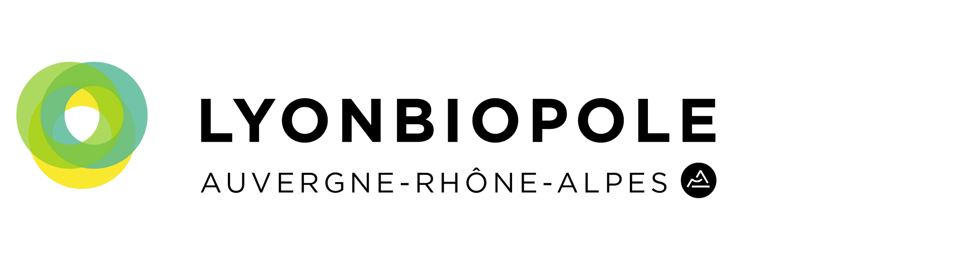

BlueSky Meeting

15th October 2024

Hôtel de Région Auvergne Rhône-Alpes - LYON



|  |  |
| --- | --- |
| **Be vigilant:** do not provide conﬁdential information - Complete the form in English or in French | |
| **Send to**: [valentin.gras@lyonbiopole.com](mailto:valentin.gras@lyonbiopole.com) before Septembre 13th at 12:00 | |
| **Contact Information** | |
| **First name** |  |
| **Last name** |  |
| **Structure** |  |
| **Position** |  |
| **Email** |  |
| **Phone** |  |
| **Categorization** | |
| **Title of your Technology/ Project** *(150 characters max)* |  |

|  |  |
| --- | --- |
|  |  |
| **Field** | e.g : Biotech – Pharma / Medtech / Digital Health / DM-DIV / Animal Health / Health Nutrition |
| **Business Model** | e.g : Service / Product / Mixed model |
| **Area(s) of application**  (3 areas max) | e.g : Bioproduction / Cardiology / Ophtalmology / Oncology |
| **Technology Readiness Level** | 1 to 9 |
| **Technology and Project pitch** | |
| **Technology/ Project Description**  (1500 characters max) | |
| **Targeted market(s)**  (1500 characters max) | |
| **Position compared to competition /state of art & Value proposition**  (1500 characters max) | |
|  | |

|  |
| --- |
| **Partnership Intended (if relevant)**  (500 characters max) |
| **Economic/Business impact**  (1500 characters max) |
| **Other information: IP Status** |
| (500 characters max) |
| **Link to Media (video or illustration, with copyrights)** |

