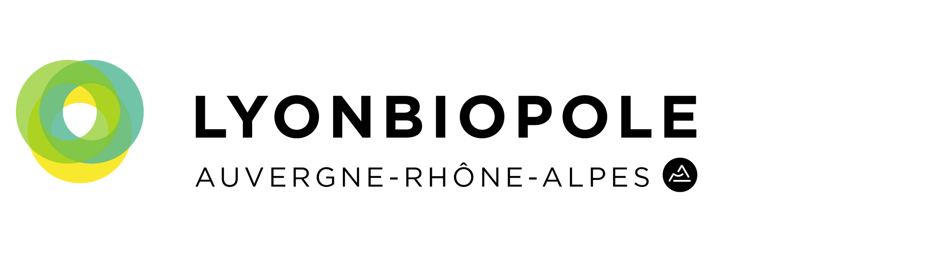
BlueSky Meeting & Poster Session 12th Edition
20th October 2023
World Trade Center, Grenoble

Be vigilant: do not provide conﬁdential information - Complete the form in English or in French
Send to: valentin.gras@lyonbiopole.com before September 25th
Contact Information
First name
Last name
Structure
Position
Email
Phone
Categorization
Title of your Technology/ Project (150 characters max)

Medical Field
Business Model
Area(s) of application
(3 areas max)
Technology Readiness Level
Technology and Project pitch
Technology/ Project Description
(1500 characters max)
Targeted market(s)
(1500 characters max)
Position compared to competition /state of art & Value proposition
(1500 characters max)

Partnership Intended (if relevant)
(500 characters max)
Economic/Business impact
(1500 characters max)
Other information: IP Status
(500 characters max)
Link to Media (video or illustration, with copyrights)

